**Brandon Green**

**green-resume**

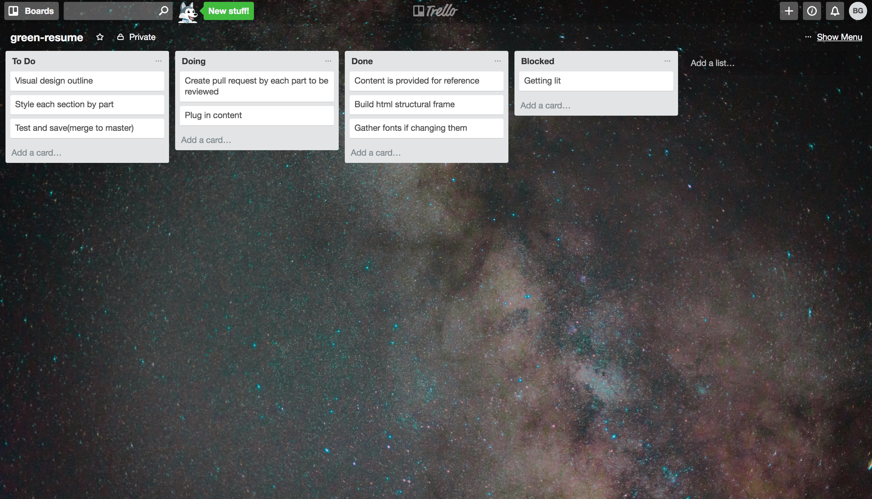

I started off the project by building my HTML structure and added fonts using Google Fonts. So far I have noticed that using a task list helps me keep myself organized, and on task. The task list has helped me remember what I was working on and what needs to get done next.

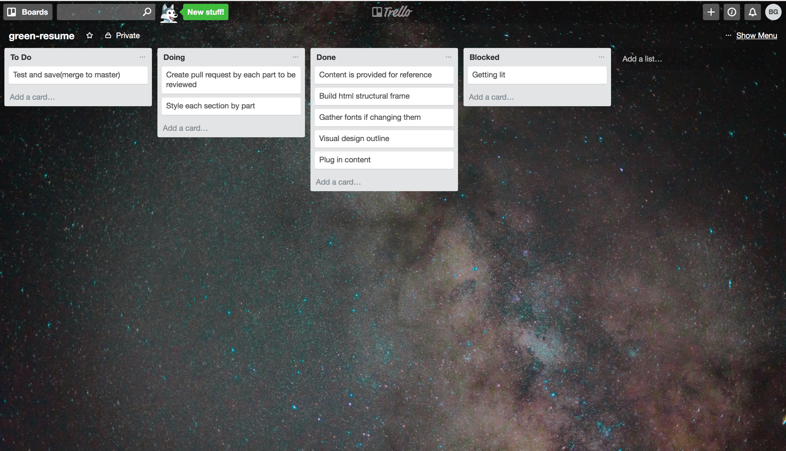

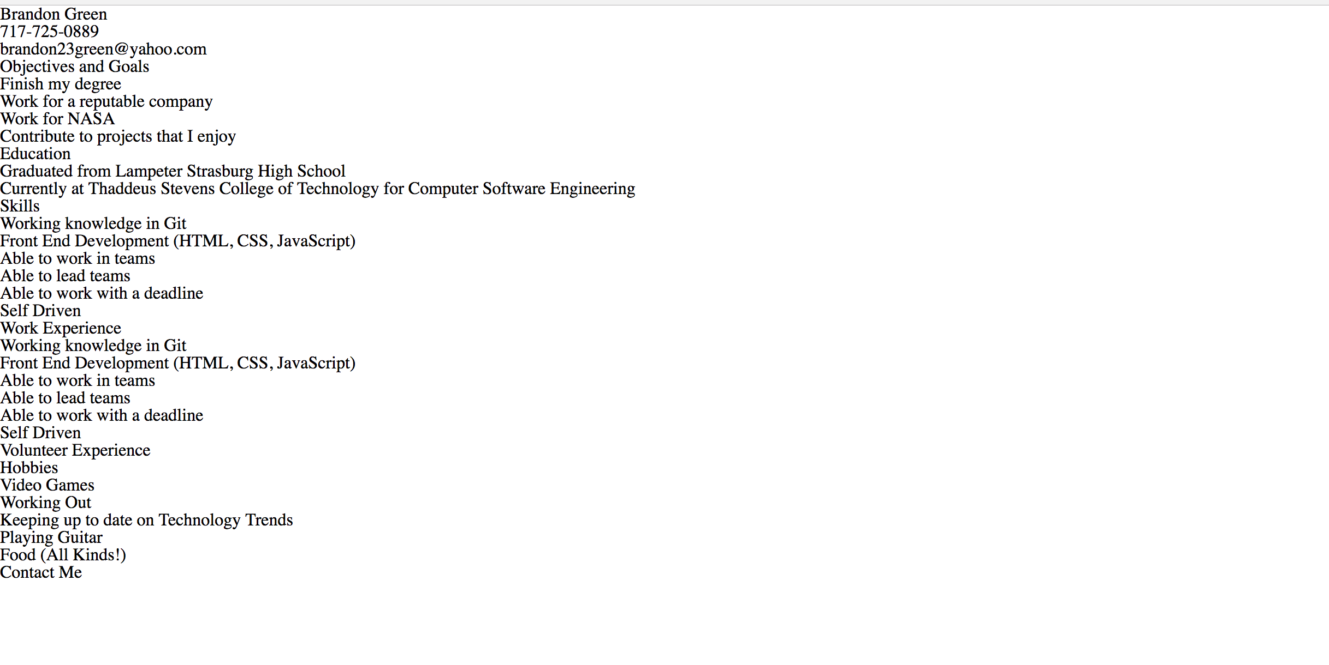

I plugged in all the content from my text file into to my code. The next step is to style each section according to the layout provided.

LINK REPO